FIFA WORLD CUP ANALYSIS DASHBOARD-POWER BI

Introduction
The purpose of this Power BI project is to analyze historical FIFA World Cup data, including matches, players, host countries, attendance, referees, and stadiums. The dashboard provides key insights and visualizations to understand performance trends, participation levels, and overall tournament statistics.
This project uses two primary datasets:
- WorldCupMatches.xlsx
- WorldCupPlayers.xlsx

Project Objectives
The main objectives of this project are:
- To visualize historical trends of attendance and participation.
- To identify the most successful countries in World Cup history.
- To analyses player-level and team-level statistics.
- To explore referee involvement and stadium usage.
- To build an interactive dashboard using KPIs, charts, and slicers.

Tools and Technologies Used
- Power BI Desktop
- Microsoft Excel (Data Source)
- DAX (Data Analysis Expressions) for calculated measures
- Power Query Editor for data transformation

Data Cleaning & Transformation
The following steps were performed using Power Query:
- Removed duplicate rows
- Standardized column names
- Changed data types (e.g., Year → Whole Number, Attendance → Whole Number)
- Removed null or irrelevant fields
- Split columns where needed (e.g., extracting City or Stadium names if required)

DAX Measures Used
KPI Measures:
- Total Players = COUNTROWS(WorldCupPlayers)
- Total Winners = DISTINCTCOUNT(WorldCupMatches[Winner])
- Total Teams = DISTINCTCOUNT(WorldCupMatches[Home Team]) + DISTINCTCOUNT(WorldCupMatches[Away Team])
- Overall Win % = DIVIDE([Total Winners], [Total Teams]) * 100
Additional Measures:
- Total Attendance = SUM(WorldCupMatches[Attendance])
- Total Matches = COUNTROWS(WorldCupMatches)
- Unique Stadiums = DISTINCTCOUNT(WorldCupMatches[Stadium])
- Qualified Teams by Year = SUM(WorldCupMatches[QualifiedTeams])

Dashboard Design & Visualizations
KPIs (Card Visuals):
- Total Players
- Total Winners
- Total Teams
- Overall Win Percentage
Visualizations:
- Bar Chart – Total Winners by Country
  - Shows which countries have won the World Cup most.
- Pie Chart – Attendance by Year
  - Displays yearly proportional attendance distribution.
- Donut Chart – Qualified Teams by Year
  - Represents the number of qualified teams per World Cup.
- Bar Chart – Referee Count by Match
  - Identifies referees with the highest match involvement.
- Line Chart – Stadium Count by City
  - Shows stadium distribution across hosting cities.
Slicers (Filters):
- Year
- Country
- Stadium
- Referee

Key Insights Derived
- Countries like Brazil, Germany, and Italy have the highest number of World Cup wins.
- Attendance trends show rising popularity in later years.
- Some referees participated in significantly more matches.
- Host cities vary widely in stadium count, with certain cities dominating.
- Number of qualified teams increased over time as FIFA expanded participation.

screenshot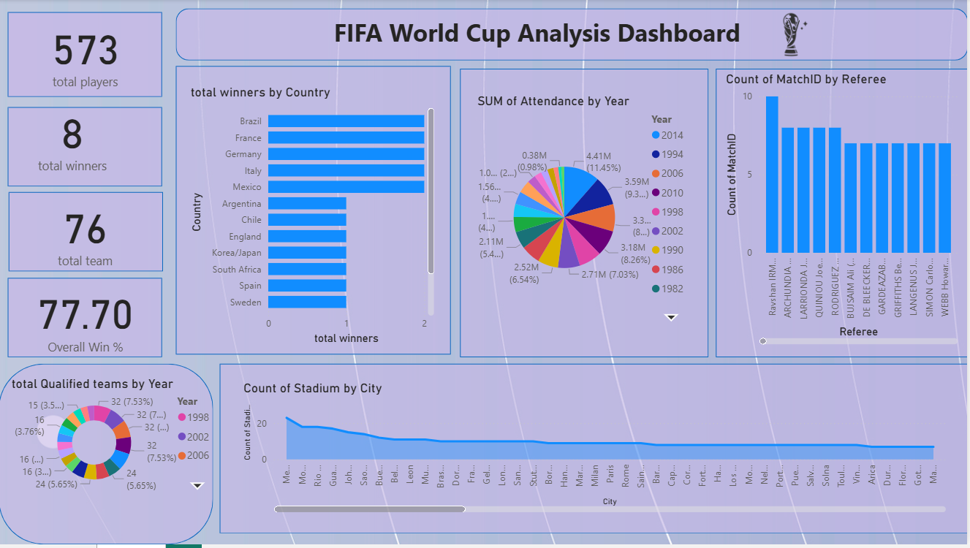

Conclusion
This Power BI dashboard provides a comprehensive analysis of FIFA World Cup history. It enables easy exploration of match trends, attendance, player statistics, stadiums, and country performance. The insights generated support deeper understanding of global football patterns and help highlight the growth and transformation of the World Cup over the years.

